**Buffalo Concussion Treadmill Test Digitalization**

| **Joshua Kent**  for Submission  Atlanta, United States  jkent40@gatech.edu | **Sami Belhareth**  for Submission  Atlanta, United States  sbelhareth3@gatech.edu | **Karan Singh**  for Submission  Atlanta, United States  karanjs@gatech.edu |
| --- | --- | --- |

**INTRODUCTION**

The Buffalo Concussion Treadmill Test (BCTT) is a metric used by trained professionals (physical therapists, certified trainers, etc.) to help patients recovering from concussions and usually those suffering from post-concussive symptoms (PCS). This project will digitalize the traditional test into a mobile iOS application and web application such that it can be conducted more efficiently. Furthermore, the digital setup will permit the use of the data for health informatics and clinical decision support in future work.

Overall, the project consists of three main aspects. First, the IOS application. This is the patient-facing interface that prompts them along the BCTT and captures biometric information like their heart rate. Second, the front-end of the web server. This will require designing an interface for the physical therapists to input notes, capture data about the patient for the BCTT, and have a portal to all previous tests. Third, the back-end of the web server. This will entail receiving the data from the iOS app, saving it in a database, and using it to track performance.

**PREVIOUS/RELATED WORK**

While there has not been substantial literature pertaining to the digitization of the BCTT, there has been work in proving the efficacy and validity of the BCTT, particularly literature detailing the relationship between BCTT performance over time and concussion recovery [1].

Using Google Scholar, we searched for the following pairs of boolean search terms: “Buffalo concussion treadmill test” AND “digital”; “Buffalo concussion treadmill test”

AND “FHIR” (acronym for fast healthcare interoperability resources, a standard in the electronic medical record field). There were no relevant search results that included these terms of interest, indicating that there is little or no work pertaining to implementing the Buffalo concussion treadmill test in a digital format.

The protocol used for conducting the BCTT test currently [2] will guide our work.

**OUR WORK**

**Web**

The web portion of the project concerns maintaining the back-end as well as front end logic. The back-end for the service is responsible for maintaining storage, individual test sessions while providing API contracts for the wearable (iOS) and the front-end client. To deploy the web application, we create a local network NodeJs server instance for the front-end client and wearable device to interface.

The front-end part of the web application is purposed for the physician assisting the patient in the treadmill test session. The view allows for the clinician to see the patient’s real-time heart rate, as well as input relevant information for the BCTT assessment, including the visual analog scale score, symptom reports, and observations. Along with providing an interface for the physician, the front-end is also responsible for fetching all the patient history from the NodeJs server. Clinicians can easily access this data and see whether a session is currently ongoing.

All information provided on the web application is synchronized with the iOS application. Thus, the interface initializes the clinician’s ability to input information in conjunction with the patient pressing the “Start Test” button on their iOS device (see Fig. 1 in appendix).

The diagram in Fig 2. illustrates the flow of communication between the three units that comprise the digital BCTT, including the front-end web application and the locally hosted back-end server.

**iOS**

The IOS portion of the project is comprised of three main aspects: (1) getting the necessary biometric data from the Apple Watch (2) creating a session between the watch and phone so this information can be communicated in real time and (3) sending this data to the web application to be used by the clinician while conducting the BCTT.

In respect to the first goal, we have successfully created a watchOS application (runs on Apple Watch) that continuously reads the user’s heart rate. On first use, the application prompts the user for permission to access their health data. After this approval, we use Apple’s HealthKit framework to query for their heart rate in real-time and display it right on the watch.

In terms of the second goal, we use WatchConnectivity to communicate between the WatchKit extension and its companion IOS app. We transfer the heart rate from the watch to the iPhone through the messaging functionality that is built into the WCSession. Once on the phone, the data is displayed so it can be viewed from both devices.

The third facet of the IOS part of the project takes advantage of REST API calls to the NodeJs server. Once the user enters their name on the app, /api/newsession is called and the inputted name is sent. A new session is created by the server, and the sessionID is returned and saved. The user is then taken to the main page where they can start the BCTT. Heart rate data and a timestamp is sent to the server every five seconds through /api/pushdata in order to create a smoother graph even though the test only requires the patient’s heart rate every minute. Finally, once the user ends the test, /api/endsession is called with the current sessionID.

Fig. 3 (in appendix) shows the Apple Watch synchronized with the iOS device, and relaying and displaying information in real time.

**DISCUSSION**

**Web**

The major challenge for the web application is designing a system that has 3 end-points (client, server and wearable peripheral) as opposed to traditional 2-endpoint client-server applications. Since the wearable sensor data and the monitoring front end both need to sync in real time, the server must provide abstracted contracts to both these clients.

We proposed a design (Fig. 1) that conceptualizes this abstraction between the front-end client and the wearable client, in this design the server acts as a synchronization mechanism between the front-end monitoring client and the sensor-enabled wearable client. Both these clients will periodically push (wearable) and pull data (front-end monitor) from the server. This real-time periodic sync is aimed to help the physician to monitor the patient’s status at every moment.

The application design can be used as a template for further development of ubiquitous medical analysis through the use of sensors present on devices that themselves are already ubiquitous. By providing this code and design to the public, we hope to spur further digitization of other tests and medical exams that are currently done on paper, and allow for clinicians to make greater use of revolutions in informatics and machine learning that have developed over the past few decades.

**iOS**

This project has taught us many new skills that we’ve previously not known until this point. Though we have IOS development experience, no team member has dealt with reading a user’s heart rate from an Apple Watch, creating companion WatchOS and IOS applications, or communicating data through both apps with a WCSession. Though we have had experience with REST API calls, we had not done them from a mobile application before this project. This taught us how to package & parse JSON and send HTTPS requests in Swift.

Overall, this process has allowed us to familiarize ourselves with a substantial amount of documentation published by Apple in the past years that not only strengthens our knowledge of mobile development, but also provides us an opportunity to implement concepts of ubiquitous computing that we’ve only learned about–not applied. In addition to the new concepts aforementioned, this work has let us learn about privacy requirements, transfer speeds, and more.

**FUTURE WORK**

**Web**

Future work for the web application would entail integrating the application with the standard electronic health record (EHR) workflow. In order to integrate with the EHR workflow, we would need to make use of specific API calls that are designed for FHIR EHR systems. Furthermore, this application would need to be deployed on the EHR system, and conform to the requirements set by the major EHR providers, namely Cerner and Epic, as this is necessary not only to seamlessly integrate, but also to ensure patient information remains protected.

Furthermore, more can be done to enhance the clinical decision support by having built-in analytics and recommendations. The web application can analyze the data for the current BCTT session and compare it to past sessions in order to make a quantitative assessment of the improvement of the patient, and provide the clinician with a recommendation. This can be done through a survey of literature to find population-level trends, and then applying those trends to our analysis methods. For example, if we find that a machine learning model can predict outcomes for concussion patients with a significant level of accuracy, then we can integrate said machine learning model for the purpose of providing guidance to clinicians.

Lastly, considerations need to be made with regards to the intuitiveness and ease of interaction for the interface. Further development can make it easier to synchronize the front-end monitoring client and the sensor-enabled wearable client.

**iOS**

Fortunately, we were able to meet the iOS goals outlined in the project proposal. The main functionality of the application has been created and future work can focus on improving the design and additional features.

More specifically, we think the WatchOS and iOS application could benefit from having a more aesthetic color scheme, font choice, and layout. Though the app has a decent look, additional beautification can improve the user experience. In terms of additional features, there are a couple components that could enhance it. First, prompting the user to tell the clinician their Rating of Perceived Exertion (RPE), condition in Visual Analogue Scale (VAS), and symptoms could remove the need for them to explicitly ask the patient this information every minute. Second, we could include some pages in the beginning of the app (before first use) that explains the instructions of the test so the patient can visually see them in addition to the clinician's verbal description. In a similar light, we can display the stopping criteria on the app so they reference it if needed.

Finally, we would like to put the application through a full user and usability testing process. Though we tested it on ourselves and peers, seeing it used by actual patients recovering from concussions can highlight errors and weaknesses that had not previously been noticed. Usability testing can highlight user experience issues that should be resolved. Like any piece of software, proper testing is needed to release high quality work, and future work should ensure this happens.

**CONCLUSION**

We have developed an iOS app in parallel with a webserver and front end capable of addressing the needs of a digital BCTT. While the BCTT test has remained largely unchanged since the late 20th century, few efforts have been made thus far to automate, digitize, or enhance the recording and analysis of the exam results. With this system, we wish to bring the BCTT into the era of EMRs and health informatics.

The first part of our system is an iOS app. The iOS app is designed to read heart rate data using the Apple Watch’s sensors, display it on both the Apple Watch and the iPhone that the Watch is connected to, and relay that information to an endpoint of interest. If this app is to be commercialized, it may need additional encryption and authentication measures, as the data being sent is protected health information.

The second part of our system is a web-app. The web app is currently able to deploy a local network NodeJS server instance in order to connect with both the front end and the Apple Watch. Future work will entail further development on the front end to integrate seamlessly with EHR systems and to automate data analysis to provide clinical decision-making assistance.

By integrating this medical test with devices that are currently in everyday use by both the clinician and the patient, we are bringing ubiquitous computing to the forefront of medicine and primary care.

The efforts presented in this paper can serve as a framework for the digitization of other medical tests, and continue to bring ubiquitous computing to the field of medicine.

**REFERENCES**

[1] Mohammad N. Haider, John J. Leddy, Charles G. Wilber, et al. 2019. The predictive capacity of the buffalo concussion treadmill test after sport-related concussion in adolescents. Frontiers in Neurology 10.

[2] John J. Leddy and Barry Willer. 2013. Use of graded exercise testing in concussion and return-to-activity management. Current Sports Medicine Reports 12, 6: 370–376.

**APPENDIX**

Fig. 1. Synchronization between the iOS application and web application.

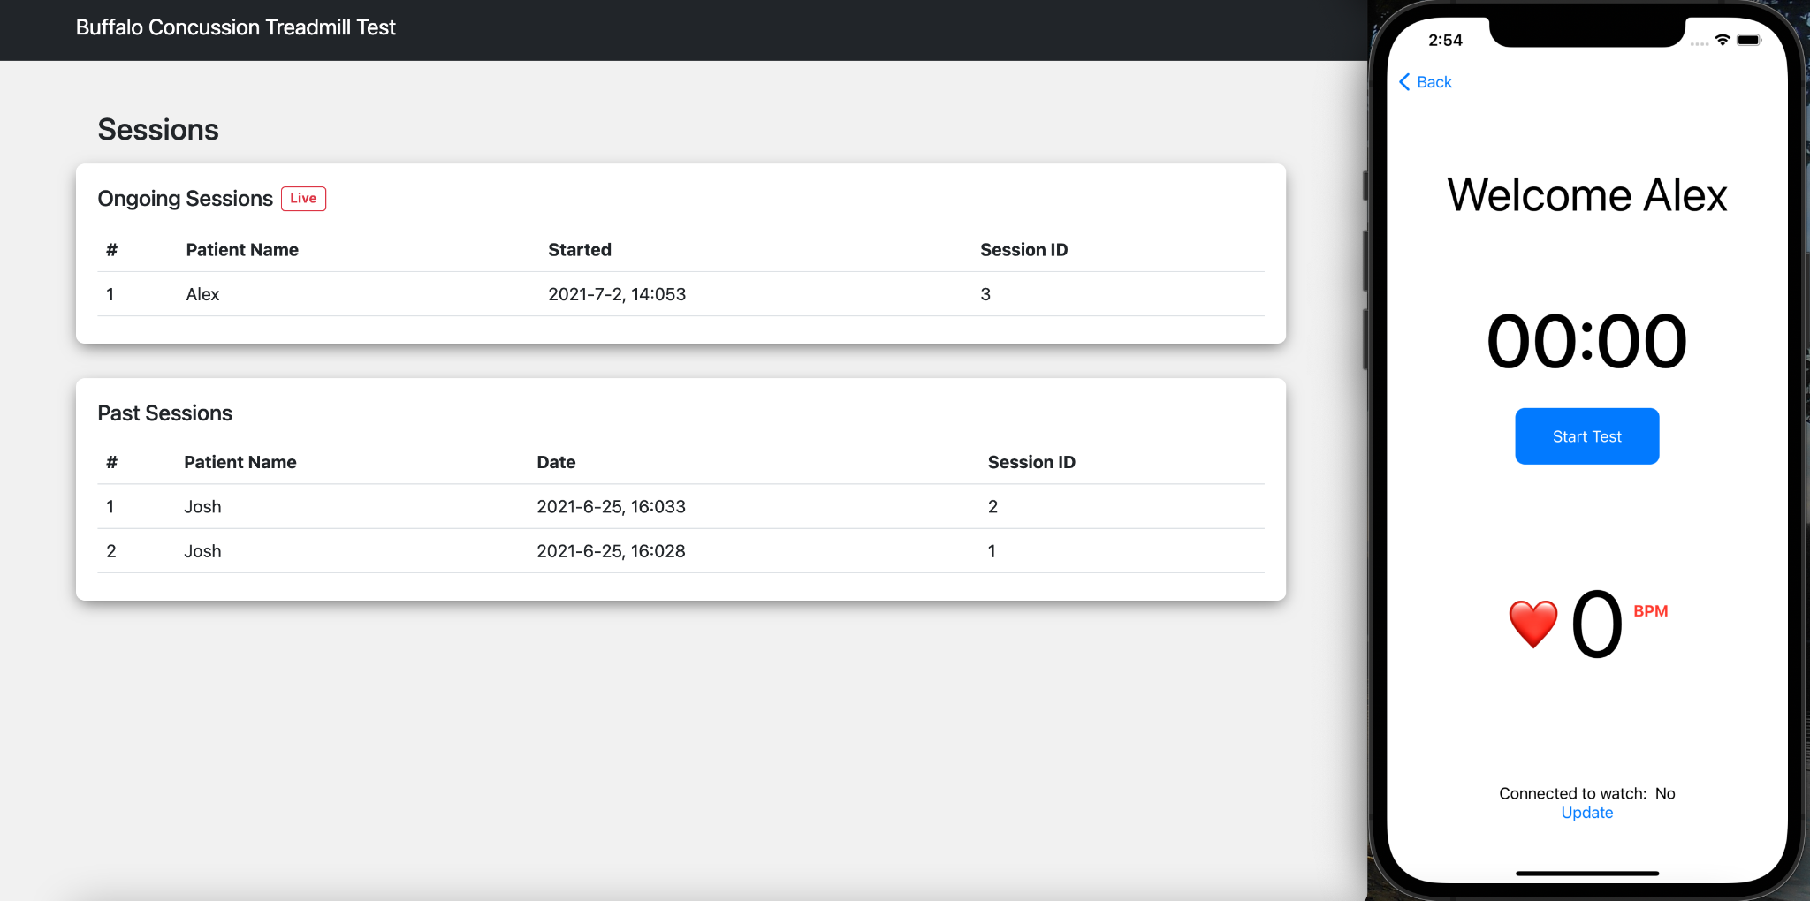

Fig. 2. Flow of communication between front-end back-end and wearable peripherals.

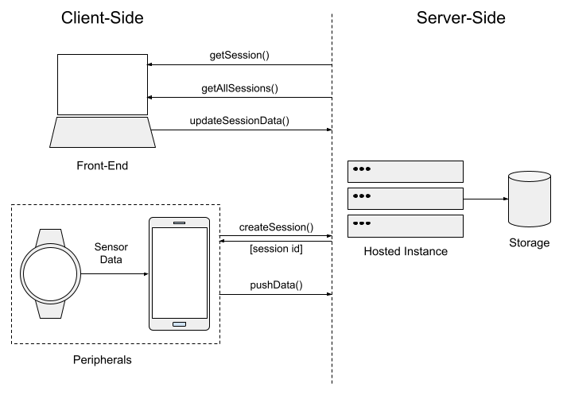

Fig. 3. Image of the WatchOS and IOS app on physical devices.

